UAT Plan

For

Heart Monitor Lanyard - Biomedical Mechatronics Solution

Index

1. Scope 2

1.1. Objectives 2

1.2. Scope 2

2. Testing team 4

3. Environmental requirements 4

3.1. Hardware requirements 4

3.2. Software requirements 4

4. Test Scripts 5

# Scope

## Objectives

The goal for this biomedical solution is to design a heart monitor for Michelle, a patient who suffers from myocardial infarction localised to the inferior of the left ventricular. The solution must suit the patient’s, Michelle’s, needs such as informing her of her heart rate and environment as well as being portable and pocket-size. The user acceptance test will help ensure all the features of the heart monitor are functional and suit the user’s needs.

Success can be measured by whether or not the solution performs the task required, the sensors are working as desired and whether the output information is useful to the user. Additionally, it would be preferable if the final design is pocket size or can fit on a lanyard and Michelle will be able to take it around with her.

## Scope

In this section, outline the scope. This means:

* What is the pain point we’re trying to fix?
* What are we testing exactly, and what are we *not* testing?

Through this solution, the heart monitor will allow Michelle to monitor her heart rate and the environment (loudness) around her which will determine whether or not it is a stressful environment. If the environment was determined to be stressful, Michelle will be able to excuse herself to prevent any further cardiovascular issues.

For this UAT test, we’d like to determine whether:

* Does the ear clip heart rate sensor detect responses
* Does the GSR measure the varying levels of perspiration of the skin
* Does the loudness sensor detect the loudness of the environment
* Does the buzzer make a buzzing sound and vibrates when other sensors detect stressful environments
* Does the OLED screen display data collected from sensors

For this UAT test, we are not testing:

* Is the product portable
* Does the product look visually appealing

## System Diagrams

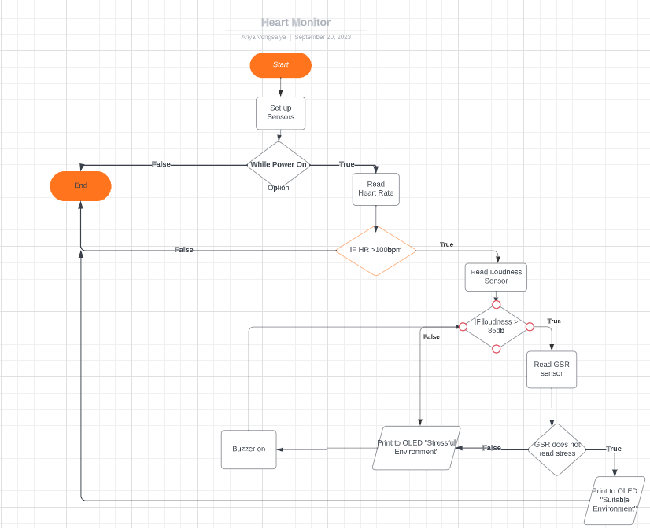

*Logic Flow Chart of Product functions*

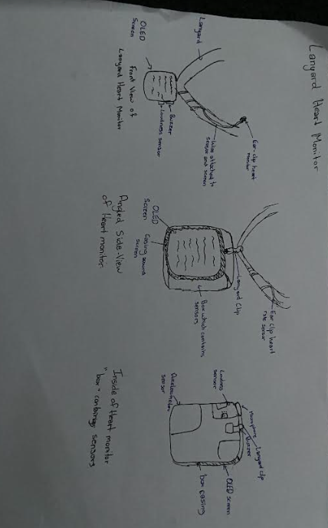

*Pictorial of Product design*

# Testing team

| **Name** | **Responsibilities** |
| --- | --- |
| Michelle | Test whether sensors are functioning and can determine user’s stress level |

# Environmental requirements

## Hardware requirements

* Heart monitor lanyard

## Software requirements

*No requirements*

## Network requirements

*No requirements*

# Test Scripts

| **Test** | **Describe the feature being tested** | **Describe the user input or test data** | **Describe the pass criteria** |  |
| --- | --- | --- | --- | --- |
| 1.1 | Stress levels of user is determined | 1. User wears lanyard around their neck 2. User turns product on 3. User places heart monitor against bare skin (chest under shirt) | 1. User sees measurements from sensors displayed on OLED screen 2. Writing displays on OLED 3. Stress level of user’s environment is determined by heart monitor | Tester name:   |  | PASS | | --- | --- | |  | FAIL |   Observations: |
| 1.2 | Heart Monitor Lanyard is user friendly | 1. User places lanyard around their neck 2. User records observations | 1. Heart monitor lanyard should fit into shirt pocket 2. Lanyard should fit comfortably around user’s neck 3. Heart monitor should not be heavy when placed around the neck 4. Heart monitor should be easy to turn on and off 5. Writing on OLED screen should be readable | Tester name:   |  | PASS | | --- | --- | |  | FAIL |   Observations: |
| 1.3 | Buzzer functions | 1. Place heart monitor around user’s neck 2. Turn the heart monitor on 3. Move to a loud environment (loudness should be over 85db) 4. Record observations | 1. Heart monitor buzzes in loud environment 2. Buzzer vibrates when loudness is over 85db | Tester name:   |  | PASS | | --- | --- | |  | FAIL |   Observations: |